(High Tech) test automation checklist
Testing a product has three major objectives:
- increase the quality of the product
- be sure of the performance
- Verify the match between the products and is specification.

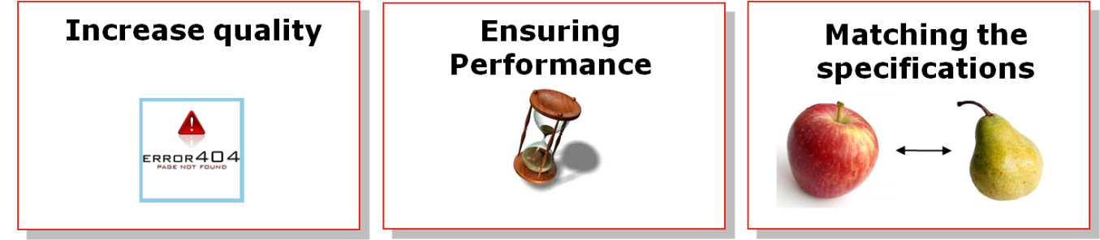
Figure 1 (B.1) Three objectives for test automation.
The aim of automation is to improve those aspects through different objectives:
- Reduction of the delay
- Reduction of the workload
- Better testing coverage
- Better testing flexibility
- Better understanding of the progress of the test process
- Increase motivation of testers by suppressing repetitive tasks to allow them concentrate and the added value part of the activity.

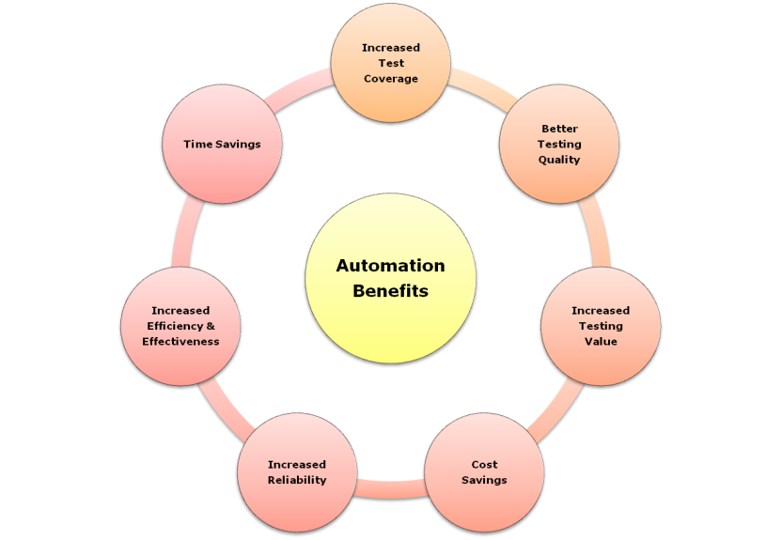
Figure 2 (B.2) From three test automation objectives a set of benefits can be achieved.
Automation can be done through the complete test lifecycle :
- Planning
  - Create Automation Test Plan
  - Automation Team Setup, identify tools
  - Identify the automation framework
  - Automation Tool license procurement
  - Analyze existing manual scripts
- Preparation
  - Identify the scenarios to be automated
  - Create traceability matrix
  - Review of the identified scenarios
  - Develop/Customize the automation framework
- Specification
  - Automation Develop automation scripts
  - Debug and test the automation scripts
  - Review the scripts and ensure coverage
  - Update traceability matrix
- Execution
  - Setup test environment
  - Perform Test Run
  - Update Automated Framework if required
  - Automatic Replay
- Completion
  - Analyze test results (traces, log...)
  - Compare results with baseline
  - Automation generation of results documents
- Test infrastructure
  - Setup the required infrastructure to develop
  - maintain and execute the automated tests
  - Setup automation lab if required
  - Automation configuration of test means
- Control
  - Capture Metrics for Test Script Creation
  - Capture Metrics for Test Execution
  - Reporting and Monitoring

